Clean Sky’s strategy for synergies in the spotlight of Shift2Rail event for the Regions

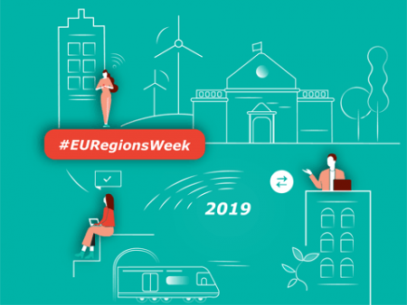

14 October 2019

Clean Sky participated in the ‘Regional Cooperation Workshop’ on 9 October that was organised by Shift2Rail as a side event of the European Week of the Regions and Cities that took place from 7-10 October in Brussels. The workshop offered stakeholders the opportunity to share expertise and success stories as well as to discuss possibilities of further enhanced cooperation.

Christos Vasilakos, Clean Sky’s Policy Officer for Synergies, presented the strategy and action plan implemented by Clean Sky 2 over the last five years. This activity has resulted so far in 18 Memoranda of Understanding (MoU) with Member States and Regions, and has triggered more than 40 pilot projects complementary to Clean Sky projects and programmes, while 11 ‘Clean Sky Synergy Labels’ have been awarded to regional partners. Additionally, in the context of the MoU cooperation, a number of Member States and Regions have launched either national or regional calls related to the Clean Sky scope and programme.

During the panel discussion Dr. Vasilakos supported that a structured Strategic Partnership, with commitments for investments and shared roadmaps, can facilitate a closer and dedicated cooperation between the JUs and regions, and enable synergies with regional research and innovation programmes and the European Structural Investment Funds (ESIF).

Learn more about Clean Sky’s work on synergies with Regions [here](https://www.cleansky.eu/structural-funds-and-regions).